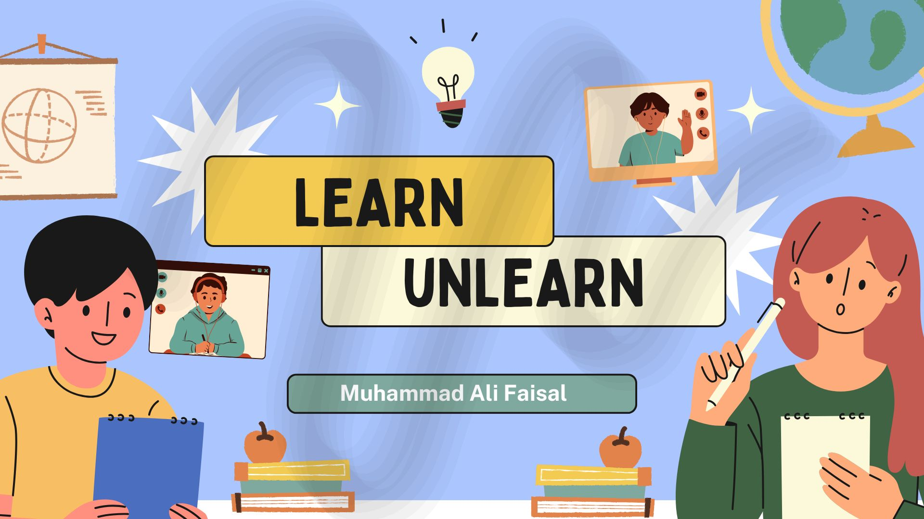

**Learn to Unlearn**

**The Secret to Real Growth in the Modern World**

We live in a world that’s changing faster than ever. New technologies, evolving job markets, shifting social norms it's all happening at lightning speed. In this dynamic environment, learning new things isn't enough. To truly thrive, we must also master something even more powerful: the art of unlearning.

🤔 **What Does “Learn to Unlearn” Really Mean?**

At first, the phrase might sound contradictory. After all, why would we want to forget what we've worked hard to learn?

But unlearning isn’t about erasing knowledge. It’s about letting go of outdated beliefs, habits, or assumptions that no longer serve us so we can make space for new ideas, new ways of thinking, and fresh perspectives.

🧠 **Why Unlearning Is So Important**

Here are a few reasons why unlearning is a vital skill in today’s world:

***1. The World Is Always Evolving***

Think about how the internet, smartphones, and AI have changed our lives. Strategies or knowledge that worked five years ago may no longer be effective today. Unlearning helps us adapt quickly to new realities.

***2. It Breaks Mental Barriers***

Old beliefs can become invisible walls that limit our potential. Unlearning challenges these mental blocks and allows innovation, creativity, and progress to flow.

***3. It Encourages Lifelong Learning***

People who are willing to unlearn stay curious and open-minded. They're not stuck in "this is how we've always done it" thinking. Instead, they embrace change and keep evolving.

💡 **Examples of Learning to Unlearn**

Here are a few everyday examples of how unlearning works:

***In Education:*** Moving away from rote memorization to critical thinking and problem-solving.

***In the Workplace:*** Letting go of old management styles in favor of collaborative, team-based leadership.

***In Personal Life:*** Replacing limiting self-talk (like "I'm not good at math") with a growth mindset ("I can improve with effort").

🚧 **The Challenge: Unlearning Is Hard**

Unlearning can be uncomfortable, even scary. We tend to cling to what we know because it feels safe. But growth lies just outside of our comfort zones.

It takes humility, awareness, and courage to admit, “Maybe I was wrong,” or “Maybe there’s a better way.”

✅ **How to Start Unlearning**

Here are a few practical steps to help you start:

***Question Everything***

Ask yourself: Why do I believe this? Is it still true? Who taught me this, and do I still agree?

***Be Open to Feedback***

Let others challenge your ideas without feeling defensive. Sometimes the best insights come from a different point of view.

***Seek New Experiences***

Travel, read widely, try new things expose yourself to diverse perspectives that push you to think differently.

***Practice Reflection***

Spend time regularly thinking about what you’ve learned and what you might need to unlearn.

***Stay Curious***

Adopt a beginner’s mindset. Even experts can benefit from thinking like a student.

🌱 **Final Thoughts: Unlearning Is the Key to Growth**

In a world that’s constantly reinventing itself, the people who succeed are not just the best learners, but also the best unlearned

So don’t be afraid to challenge your old ways of thinking. Let go of what no longer serves you. Make space for something better.

Because sometimes, the first step to truly learning something new… is to unlearn what you thought you knew.